**Date: 17/08/2020 Reg. No.: 19BCE0977**

**Slot: L3 + L4 Name: Swaranjana Nayak**

**EXPERIMENT 2**

**EXPERIMENT 2C**

**AIM:**

**To write a shell script program to find the factorial of a given number using while loop.**

**CODE:**

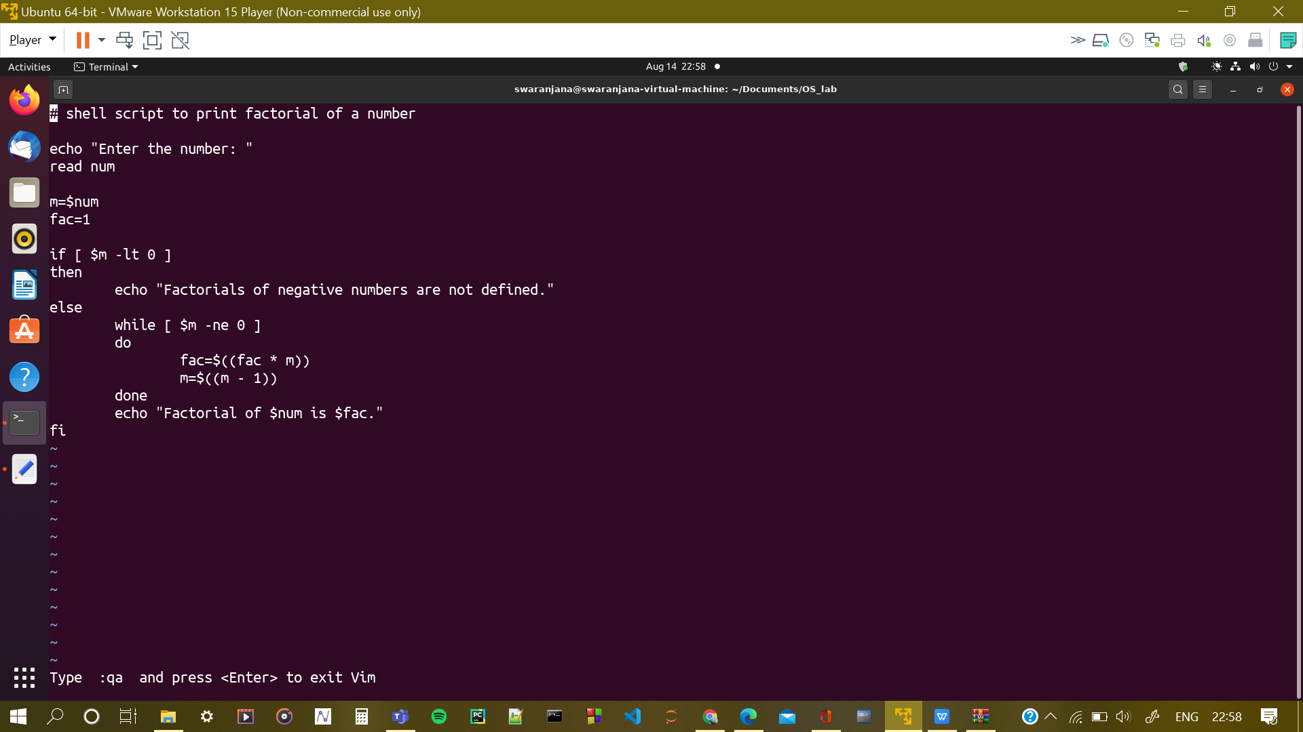

**OUTPUT:**

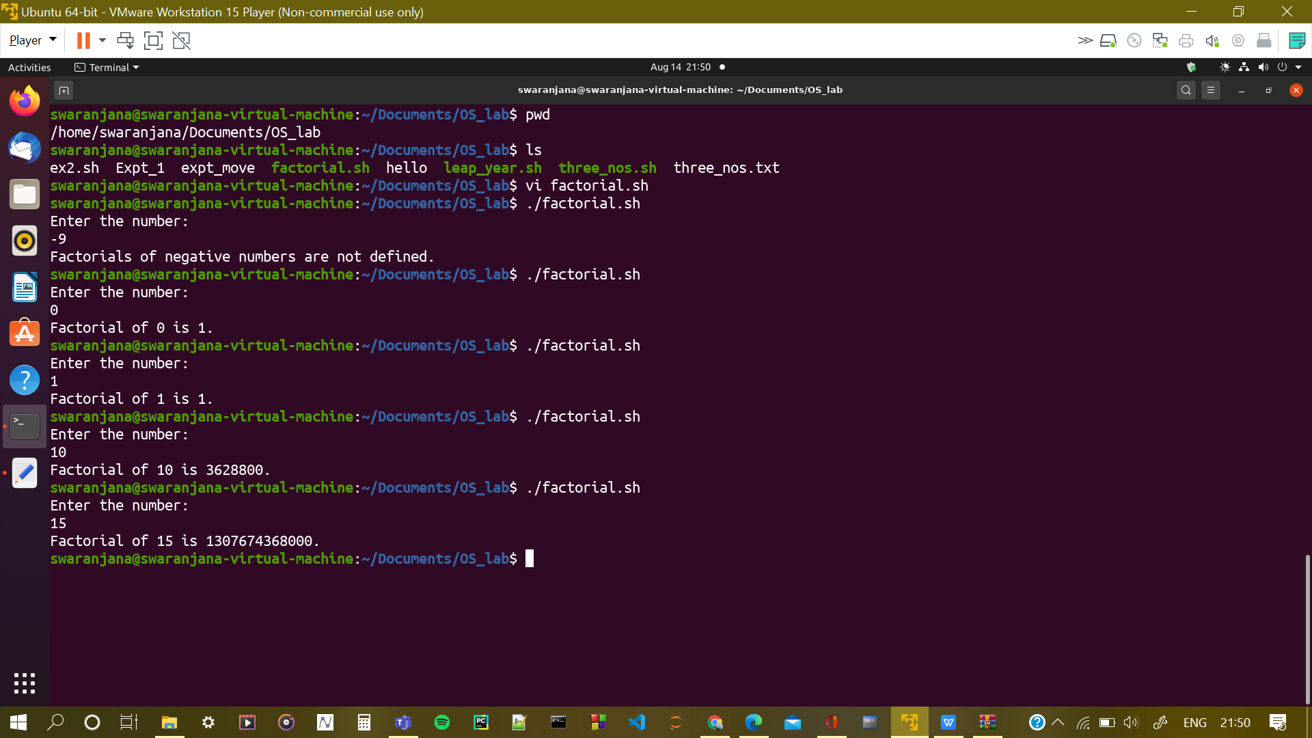

**RESULT:**

**The program to print factorial of a given number was implemented in shell script using vi editor, and it executes correctly.**

**EXPERIMENT 2D**

**AIM:**

**To write a shell script program to reverse a given number using while loop.**

**CODE:**

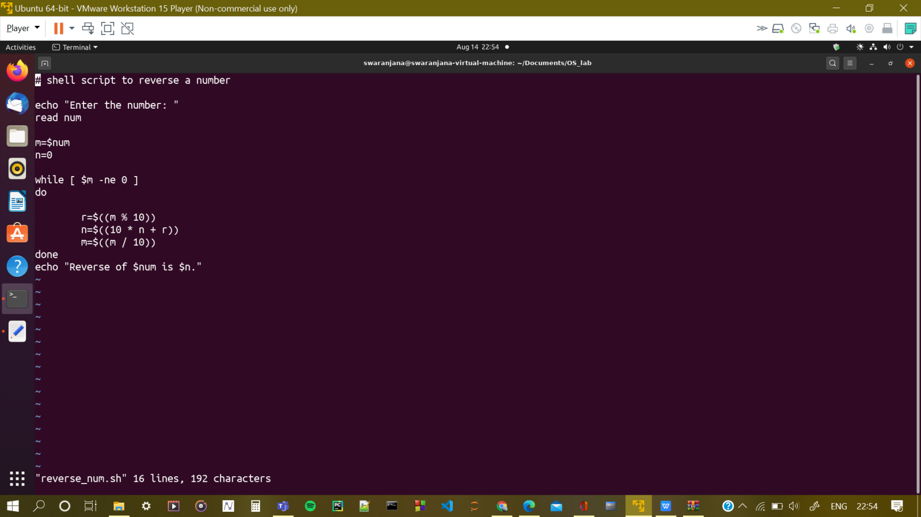

**OUTPUT:**

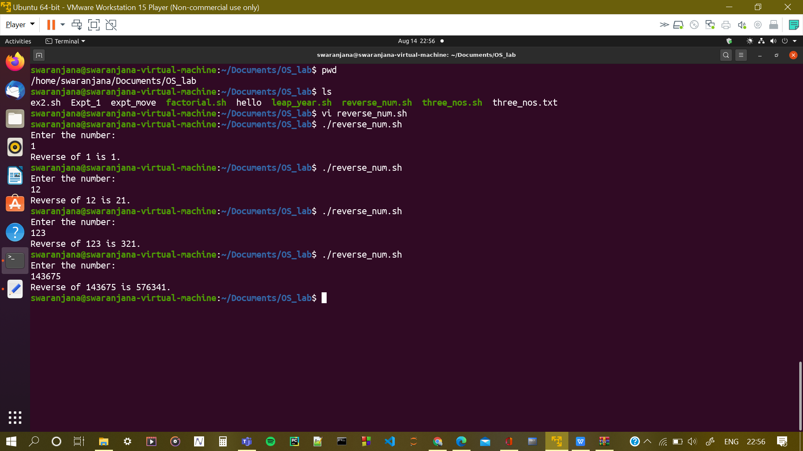

**RESULT:**

**The program to reverse a given number was implemented in shell script using vi editor, and it executes correctly.**